**SYST10199 Web Programming Instructor: Amandeep S. Patti Assignment 3**

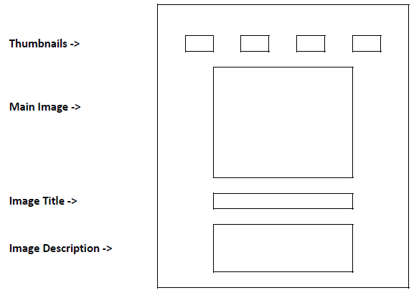

**Instructions:**

1. Create an HTML document to implement an image gallery.
2. Add detailed image description (may be 3-4 sentences) to all thumbnails (use alt attribute to store image description).
3. Add title to all thumbnails (use title attribute to store the image title).
4. Create two HTML elements below the main image tag; one for showing the image title (use H1 tag) and another for showing the image description (use P tag).
5. On moving your mouse over the thumbnails, implement the followings (using a suitable user-defined function):
   1. Change the border color of thumbnails.
   2. Display the thumbnail image in main image area.
   3. Display the thumbnail title in H1 tag.
   4. Display the thumbnail description in P tag.

**Notes**:

* Make sure to implement the step 5 using suitable function call
* You are required to complete this lab INDEPENDENTLY WITHOUT ANY OUTSIDE COLLABORATION.

**GOOD LUCK!**